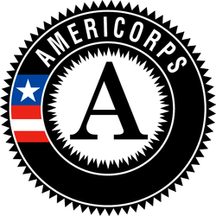
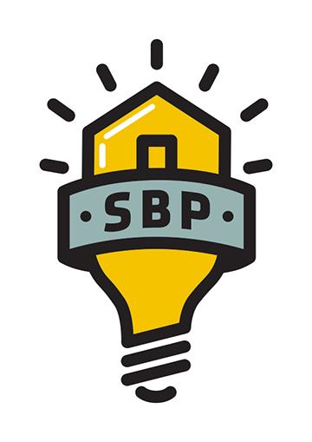
SBP AmeriCorps Client Services Coordinator

Service Position Summary:
SBP is an award-winning, nonprofit rebuilding organization whose mission is to ensure that disaster-impacted citizens and communities recover in a prompt, efficient and predictable manner. Through Disaster Recovery Lab, SBP works to share lessons learned, prevent common barriers to recovery and help communities utilize SBP’s standardized, repeatable and proven-effective model. Since its founding in 2006, in response to Hurricane Katrina, SBP has rebuilt homes for over 2300 families with the help of over 130,000 volunteers in New Orleans and Baton Rouge, LA; Joplin, MO; Rockaway, NY; Monmouth and Ocean Counties, NJ; San Marcos, TX; Columbia, SC; Houston, TX; Bay County, FL; North Carolina; and Puerto Rico.
A Client Service Coordinator is a liaison to SBP’s clients from application to completion of construction and move-in while working with clients to remove barriers to their recovery from disaster.
Essential Functions of Position:
- Move each of your 30-40 clients closer to moving into their rehabilitated homes.
- Interview prospective clients and work with them to complete an application for assistance.
- Present prospective client cases to Executive Director and/or Client Services Manager for acceptance into SBP programs.
- Assist clients in completing applications to utilize available funding programs earmarked for the recovery needs of disaster-impacted individuals in the local community and assist the client in navigating these programs throughout the rebuilding process.
- Research and refer clients who are in need of housing, food, or other needs to appropriate services.
- Act as a reliable point of contact for the client throughout the rebuilding process; ensuring client understands where they are located in the program pipeline at all times.
- Track client progress and report weekly to Client Services Manager on progress.
- Input client data and upload documents into client database (Salesforce); update case notes daily.
- Support and promote the client both with outside organizations and internally within SBP.
- Learn, understand, and perform SBP’s expectations for project site and personal safety as outlined in the Construction Manual and Safety While Serving at SBP, as well as safety trainings occurring throughout the term on site or during departmental meetings
- Participate in September 11th Day of Remembrance and Martin Luther King Jr. Day of Service events, which may take place on a weekend or during holidays and include activities outside of the scope of typical day-to-day functions.
  - Per 45 CFR §2510.20, SBP has determined that the probability of access to vulnerable populations is so great that all members will receive the three part NSCHC: NSOPR, FBI, and required state components (residence and state of service, as necessary).
  - Per 45 CFR §2540.100, member activities are not supplementing, duplicating, or displacing staff or volunteers.

Knowledge, Skills, and Abilities Required:
- Be at least 17 years of age or older.
- Have a high school diploma or its equivalent
- Be a citizen, national, or lawful permanent resident alien of the United States
- Satisfy the National Service Criminal History Check eligibility criteria pursuant to 45 CFR 2540.202.
- Strong interpersonal skills, including active listening.
- Ability to maintain a calm, professional demeanor in challenging situations, including client crises.
- Ability to clearly communicate needs and expectations to people of various backgrounds.
- Demonstrated problem solving skills.
- Fluency in Spanish required for positions serving at the Puerto Rico Operating Site

Academic, Experience, and Core Competencies Needed: The AmeriCorps member should demonstrate the following competencies to perform the essential functions of this position:
- Flexibility/Resilience – The ability to adjust to and thrive in a complex and changing environment; handles setbacks and failures with professionalism and candor; effectively and appropriately responds in the face of adversity or conflict.
- Ability to Work Independently – The ability to be a self-starter and accomplish tasks independently and without constant direct supervision.
- Ability to Multi-Task – The ability to handle multiple tasks and assignments; prioritizes more important tasks while maintaining a good handle on others; reports in a timely manner any barriers to task completion and allows ample opportunities for supervisor to adjust deadlines
- Results-Oriented Thinking and Behavior – A genuine concern for effectiveness. Possesses the desire to get the service done with excellence; mentally, is focused on getting the best results for actions taken; does not settle for mediocrity.
- Awareness and Sensitivity to the External Environment – Situational awareness; is aware of the organizations that they represent, including CNCS, AmeriCorps, and SBP, and the effect of their words and actions on that position; demonstrates savvy in dealing with agencies, volunteers and donors; is promoting and affirming in conversations about and on behalf of those organizations.
- Physical Activities:
  - Manual Dexterity: Picking, pinching, typing or otherwise serving, primarily with fingers rather than with the whole hand or arm as in handling.
  - Communicating: Expressing or exchanging ideas. Activities must convey detailed or important spoken instructions to others accurately, loudly or quickly.
  - Listening: Ability to receive detailed information through appropriate communication.
- Visual Acuity: Member is required to have close visual acuity to perform an activity such as: preparing and analyzing data and figures; transcribing; viewing a computer terminal; and/or expansive reading.
- Service Conditions: Member is subject to both inside and outside environmental conditions.

Commitment Required: Full Time members will serve 1700 hours. Members are required to serve 42 hours a week. A typical service week is Monday – Friday, however volunteer events often occur on Saturday and will require attendance. Member will have ample opportunity to complete 1700 hours of service.

Member Evaluation: Members will receive mid-year and end of year evaluations, as well as complete necessary weekly and/or monthly data reports and bi-weekly timesheets in OnCorps.

Training:
- Members will receive service and site-specific training to prepare them for their service. Members will also be required to attend orientation.
- Member training hours meet the requirements of 45 CFR §2520.50.
AmeriCorps Program Benefits:
This position is eligible for a living allowance, post-service education award, health benefits, loan forbearance for most federally-guaranteed student loans, and childcare assistance. The stipend for this position is $1,427.90 per month and may not exceed $14,279.00 for the entire term of service. The education award for this position upon completion of the ten-month term and 1700 hours of service is $6195. Please visit http://www.americorps.gov/for_individuals/benefits/benefits_ed_award.asp for more information on the education award. AmeriCorps members in this position have the opportunity to make a difference in communities, connect to a national AmeriCorps network and alumni group, and serve with a dynamic team of members.

