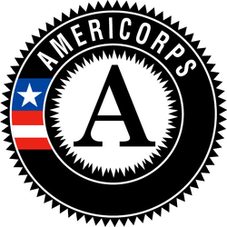
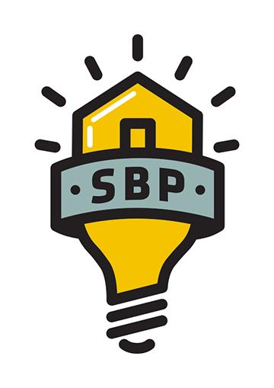
SBP AmeriCorps Construction Coordinator

Service Position Summary:
SBP is an award-winning, nonprofit rebuilding organization whose mission is to ensure that disaster-impacted citizens and communities recover in a prompt, efficient and predictable manner. Through Disaster Recovery Lab, SBP works to share lessons learned, prevent common barriers to recovery and help communities utilize SBP’s standardized, repeatable and proven-effective model. Since its founding in 2006, in response to Hurricane Katrina, SBP has rebuilt homes for over 2300 families with the help of over 130,000 volunteers in New Orleans and Baton Rouge, LA; Joplin, MO; Rockaway, NY; Monmouth and Ocean Counties, NJ; San Marcos, TX; Columbia, SC; Houston, TX; Bay County, FL; North Carolina; and Puerto Rico.
Construction Coordinators play a vital role in the process of building our client’s homes. Construction Coordinators ensure construction sites are provided and tracked with necessary tools and materials on time and accurately so that our Project Managers and Site Supervisors have what they need when they need it.
Essential Functions of Position:
- Assist with permits by dropping off permit applications.
- Schedule inspections with the building department and funders as needed for each construction projects.
- Identify potential new subcontractors and maintain sub-contractor database and folders with proper documentation.
- Coordinate and schedule times for subcontractors to complete work on clients’ homes.
- Attend walkthroughs with Project Managers and subcontractors and receive bids from subcontractors and place in their folders.
- Order and process utilities and special orders for sites; i.e. dumpsters, drywall, etc.
- Ensure all electronic construction files, Gantt charts, excel tracking documents, and white boards are up to date with accurate information
- Learn, understand, and perform SBP’s expectations for job site and personal safety as outlined in the Construction Manual and Safety While Serving at SBP, as well as safety trainings occurring throughout the term on site or during departmental meetings
- Participate in September 11th Day of Remembrance and Martin Luther King Jr. Day of Service events, which may take place on a weekend or during holidays and include activities outside of the scope of typical day-to-day functions.
  - Per 45 CFR §2510.20, SBP has determined that the probability of access to vulnerable populations is so great that all members will receive the three-part NSCHC: NSOPR, FBI, and required state components (residence and state of service, as necessary).
  - Per 45 CFR §2540.100, member activities are not supplementing, duplicating, or displacing staff or volunteers.

Knowledge, Skills, and Abilities Required:
- Be at least 17 years of age or older.
- Have a high school diploma or its equivalent
- Be a citizen, national, or lawful permanent resident alien of the United States
- Satisfy the National Service Criminal History Check eligibility criteria pursuant to 45 CFR 2540.202.
- Strong interpersonal skills, including active listening.
- Ability to maintain a calm, professional demeanor in challenging situations, including client crises.
- Ability to clearly communicate needs and expectations to people of various backgrounds.
- Demonstrated problem solving skills.
- Fluency in Spanish required for positions serving at the Puerto Rico Operating Site

Academic, Experience, and Core Competencies Needed:
- Excellent verbal communication skills
- Strong organizational skills and ability to delegate tasks effectively
- Assist other departments in major projects as needed as it relates directly to the AmeriCorps program
- Ability to work under pressure
- Ability to multitask
- Experience/ Interest in developing project management skills
- Willingness/ enthusiasm to receive constructive feedback from your manager and peers
- Positive attitude
- Ability to take initiative and be self-motivated
- High regard for safety
- Valid and current Driver’s license
- Strong passion for the work of SBP

Commitment Required: Full Time members will serve 1700 hours. Members are required to serve 42 hours a week. A typical service week is Monday – Friday, however volunteer events often occur on Saturday and will require attendance. Member will have ample opportunity to complete 1700 hours of service.

Member Evaluation: Members will receive mid-year and end of year evaluations, as well as complete necessary weekly and/or monthly data reports and bi-weekly timesheets in OnCorps.

Training:
- Members will receive service and site-specific training to prepare them for their service. Members will also be required to attend orientation.
- Member training hours meet the requirements of 45 CFR §2520.50.
AmeriCorps Program Benefits:
This position is eligible for a living allowance, post-service education award, health benefits, loan forbearance for most federally-guaranteed student loans, and childcare assistance. The stipend for this position is $1,427.90 per month and may not exceed $14,279.00 for the entire term of service. The education award for this position upon completion of the ten-month term and 1700 hours of service is $6195. Please visit http://www.americorps.gov/for_individuals/benefits/benefits_ed_award.asp for more information on the education award. AmeriCorps members in this position have the opportunity to make a difference in communities, connect to a national AmeriCorps network and alumni group, and serve with a dynamic team of members.

