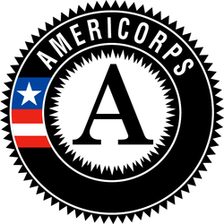
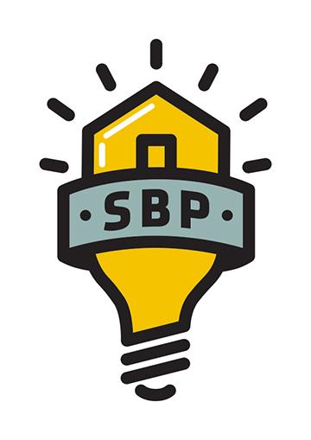
AmeriCorps Framing Carpenter

Service Position Summary:
SBP is an award-winning, nonprofit rebuilding organization whose mission is to ensure that disaster-impacted citizens and communities recover in a prompt, efficient and predictable manner. Through Disaster Recovery Lab, SBP works to share lessons learned, prevent common barriers to recovery and help communities utilize SBP’s standardized, repeatable and proven-effective model. Since its founding in 2006, in response to Hurricane Katrina, SBP has rebuilt homes for over 2300 families with the help of over 130,000 volunteers in New Orleans and Baton Rouge, LA; Joplin, MO; Rockaway, NY; Monmouth and Ocean Counties, NJ; San Marcos, TX; Columbia, SC; Houston, TX; Bay County, FL; North Carolina; and Puerto Rico.
Skilled Construction Specialists serve in small crews alongside fellow AmeriCorps members to complete the requisite carpentry work at our clients' homes. Skilled Construction Specialists learn how to execute the construction of floor systems, building walls, drying-in homes, and other various tasks including decks and stairs. Members will learn hands on building and come away with extensive knowledge, problem solving skills, and leadership opportunities.

Skilled Construction Specialist​s​ will be responsible for training and managing​ ​skilled and unskilled volunteers in construction projects​, keeping them on task, maintaining a safe and clean worksite, monitoring safety and quality​, ​ and ensuring tasks are completed on schedule.

Essential Functions of Position:
- Maintain a clean, safe and organized work site.
- Ensure that work is of the highest quality.
- Maintain a professional and positive attitude when working with volunteers and members.
- Interact effectively and positively with other team members.
- Ability to learn and implement building plans and install procedures to SBP's standard
- Use hand tools, nail guns, and power tools to complete skilled construction tasks.
- Review work orders and preparing material list for completion of jobs.
- Ensure the safe and proper use of tools and equipment.
- Participate in September 11th Day of Remembrance and Martin Luther King Jr. Day of Service events, which may take place on a weekend or during holidays and include activities outside of the scope of typical day-to-day functions.
  - Per 45 CFR §2510.20, SBP has determined that the probability of access to vulnerable populations is so great that all members will receive the three part NSCHC: NSOPR, FBI, and required state components (residence and state of service, as necessary).
  - Per 45 CFR §2540.100, member activities are not supplementing, duplicating, or displacing staff or volunteers.

Requirements:
- Be at least 17 years of age or older.
- Have a high school diploma or its equivalent
- Be a citizen, national, or lawful permanent resident alien of the United States
- Satisfy the National Service Criminal History Check eligibility criteria pursuant to 45 CFR 2540.202.
- Strong interpersonal skills, including active listening.
- Ability to maintain a calm, professional demeanor in challenging situations.
- Willingness /enthusiasm to receive constructive feedback from your supervisor and peers
- Ability to complete physical demanding work outdoors in extreme weather conditions (high/low temperatures, strong wind/rain, direct sunlight, etc.)
- Strong passion for the work of the SBP
- Demonstrated problem solving skills.
- Fluency in Spanish required for positions serving at the Puerto Rico Operating Site

Core Competencies Needed:
- Excellent verbal communication skills
- Experience/comfort with public speaking
- Ability to lead diverse groups of volunteers on a wide array of tasks (that will most likely be new to you)
- Ability to perform physical labor, occasionally strenuous
- Ability to lift at least 50 lbs.
- Strong organizational skills and ability to delegate tasks effectively
- Experience/interest in developing project management skills
- Willingness /enthusiasm to receive constructive feedback from your supervisor and peers
- Positive attitude
- Ability to take initiative and be self-motivated
- High regard for safety
- Strong passion for the work of SBP
- No construction experience necessary, although helpful, as this is a construction heavy position.

Commitment Required: Full Time members will serve 1700 hours. Members are required to serve 42 hours a week. A typical service week is Monday – Friday, however volunteer events often occur on Saturday and will require attendance. Member will have ample opportunity to complete 1700 hours of service.
Member Evaluation: Members will receive mid-year and end of year evaluations, as well as complete necessary weekly and/or monthly data reports and bi-weekly timesheets in OnCorps.
Training:
- Members will receive service and site specific training to prepare them for their service. Members will also be required to attend orientation.
- Members will receive on-site construction training that occurs at project houses for the first six – eight weeks of service. Training occurs during project builds, and may include demonstrating tasks to managers, members, and volunteers.
- Member training hours meet the requirements of 45 CFR §2520.50.
AmeriCorps Program Benefits:
This position is eligible for a living allowance, post-service education award, health benefits, loan forbearance for most federally-guaranteed student loans, and childcare assistance. The stipend for this position is $1,427.90 per month and may not exceed $14,279.00 for the entire term of service. The education award for this position upon completion of the ten-month term and 1700 hours of service is $6195. Please visit http://www.americorps.gov/for_individuals/benefits/benefits_ed_award.asp for more information on the education award. AmeriCorps members in this position have the opportunity to make a difference in communities, connect to a national AmeriCorps network and alumni group, and serve with a dynamic team of members.

